PHENOMENOLOGY OF VECTOR RESONANCES AT FUTURE e+e- COLLIDERS

D. Bruncko, bruncko@saske.sk, IEP SAS Košice, M. Gintner, gintner@fyzika.utc.sk and I. Melo, melo@fyzika.utc.sk, University of Žilina

INTRODUCTION

The origin of electroweak symmetry breaking is still a mystery. One of several possible solutions and an important alternative to supersymmetry is strongly-coupled electroweak symmetry breaking (SEWSB). SEWSB gives rise to massless Goldstone bosons ('EW pions') which, just like QCD pions, are assumed to be bound states of some more fundamental strongly interacting objects (e.g. technifermions). According to Higgs mechanism, EW pions become (longitudinal) W and Z bosons (V_{L}). Since V_{L} V_{L} → V_{L} V_{L} amplitudes violate unitarity at 1-3 TeV range, we expect new SEWSB resonances to appear around this energy scale.
Many studies have concentrated on the production and signatures of new scalar (S) and vector (ρ) resonances in V_{L} V_{L} → V_{L} V_{L} scattering at future e+ e- colliders (LC) and LHC [1].
In this work we study signatures of new (I=J=1) resonances from SEWSB in a related process V_{L} V_{L} → tt which is part of the process e+e- →ννtt at LC. The main appeal of this process is in the possibility to test whether the top quark mass is generated by the same new interactions which are responsible for SEWSB, or by yet additional new strong interactions introduced just to explain the top mass [1,2]. The previous studies of this process concentrated mostly on the Standard model [3].

LAGRANGIANS DESCRIBING ρ RESONANCE

We first consider a simple or 'natural' Lagrangian given in (Eq. 1). It describes general couplings of a neutral vector resonance (ρ⁰) with charged scalar particles - π's (to which are W_{L}'s effectively reduced at E >> M_{W}) and top antitop pair.

L = i g_{π} M_{ρ}/v (π⁻ ∂^{μ}π⁺ - π⁺ ∂^{μ}π⁻ )ρ⁰ _{μ}+ g_{V} t γ^{μ} t ρ⁰ _{μ}
+ g_{A} t γ^{μ} γ⁵ t ρ⁰ _{μ} (1)

This simple Lagrangian is very useful but it does not address the interactions of ρ⁰ with the remaining fields of the Standard Model. Therefore we will also consider chiral effective L (based on SU(2)_{L} x SU(2)_{R} global and SU(2)_{L} x U(1)_{Y} local,) which is an example of more complete and at the same time still quite general ρ resonance model. We discuss this model in detail in Ref. [4], here (Eq. 2) we show just few relevant terms with four paramters a, g'', b_1, b_2:

L = - v² Tr [ A_{μ} A^{μ}] - a v² /4 Tr[(ω_{μ} + i g'' ρ_{μ} . τ/2 )²]
+ b₁ I^{b}_{L} + b₂ I^{b}_{R} + ... (2)

Assuming g_{V} = g_{A} (b_1 = 0), the two sets of parameters in Eqs. 1,2 (and hence the two Lagrangians) are related via g_{π} = M_{ρ} /(2 v g''), g_{V} ≈ g'' b₂ /[4(1+b_2)], M_{ρ} ≈ √a v g''/2.
We can place both unitarity and low energy constraints
on these parameters. Unitarity constraints come from the study of amplitudes for V_{L} V_{L} → V_{L} V_{L}, V_{L} V_{L} → tt , tt → tt with ρ present - they indicate the parameter value at which one of the amplitudes starts to violate tree level (perturbative) unitarity (in a sense similar to Higgs violating the tree level unitarity for M_{H} > 1 TeV):

g_{π} < 1.5, g_{V} < 2.0 (M_{ρ} = 1 TeV) (3)

Low energy constraints come from modifications of Ztt, Zbb, Wtb SM couplings by ρ model at LEP energies when much heavier ρ is integrated-out of the particle spectrum. Our analysis of experimental limits on ε parameters yields [4]:

g'' ≥ 10, |b_2| ≤ 0.08 (4)

Signal and background calculations

We calculated the cross section for the signal (e+e- →ννtt) in two independent ways. In the first approach we selected from the complete tree level set of Feynman diagrams the subset of fusion diagrams, employed effective W (EWA) and equivalence theorem (ET) approximations and implemented resulting amplitudes in Pythia.
In the second approach we implemented the chiral Lagrangian into CompHEP and calculated the full
set of 66 tree level diagrams without any approximation. The results agreed with Pythia to a level better than
10 % at energies above1500 GeV. As an example we give in Eq. 5 the total cross sections for a ρ with the mass M = 700 GeV and the width Г= 12.5 GeV (g'' = 20, b₂ = 0.08) at energies 800 GeV, 1000 GeV and 1500 GeV before the cuts (to be defined below).

σ (√s = 0.8 TeV) = 0.66 fb
σ (√s = 1.0 TeV) = 1.16 fb
σ (√s = 1.5 TeV) = 3.33 fb (5)

Two most important background processes are
e+ e- → tt γ and e+ e- → e+ e- tt . We simulated the two processes with Pythia and found that after we impose the following cuts at √s = 1000 GeV - M_{tt} > 500 GeV,p_{T} (tt) > 15 GeV, m_{recoil} > 150 GeV, |cos θ_{t,t}| < 0.8, P_{T}(t) > 20 GeV, E_{miss} > 100 GeV, |cos θ_{miss}| < 0.96, the total background is reduced from 207.3 fb to 0.035 fb, while signal is reduced from 1.16 fb (Eq.5) to 0.16 fb.

For √s = 800 GeV, similar cuts reduce the total background from 301.6 fb to 0.13 fb.
To see what the chances are that the observed number of events indeed corresponds to a ρ resonance rather than to the fluctuation of the no resonance case plus the background, we define quantity R in terms of total event numbers N after cuts as

R = |N(ρ) - N(no resonance)|/√(N(Background)
+ N(no resonance)) (6)

R = 3 means that we are 3 σ away from the no resonance. For an M = 700 GeV (Г = 12.5 GeV) ρ we
plot R as a function of ρ couplings g‘‘ and b₂ at √s = 1000 GeV in Figs. 1a,b.

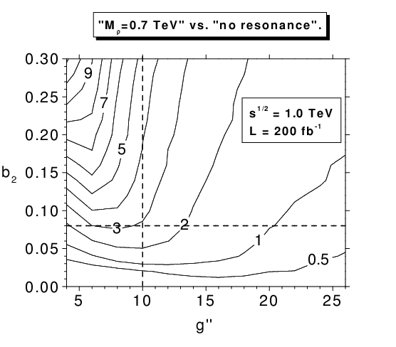
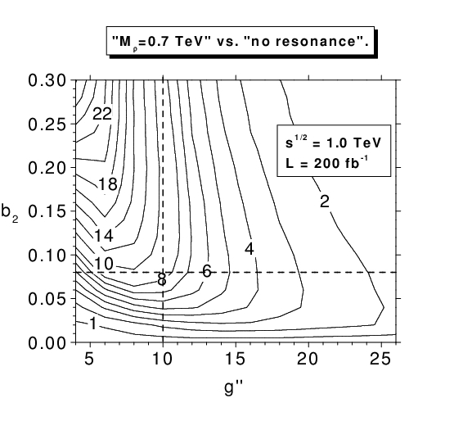

Fig. 1a,b: R contours as a function of couplings g‘‘ and b₂ at √s = 1000 GeV and total integrated luminosity of
200fb⁻¹ .
Fig. 1a (top) shows R contours for basic set of cuts defined in the text, while Fig. 1b (bottom) shows the improvement when the cut 670 <m_{tt} < 730 GeV is applied. Also shown are low energy limits (dashed lines). The allowed region is in the lower right corner.

Conclusions

We calculated e+e- →ννtt cross sections in the
framework of new strong ρ resonance model motivated by SEWSB. We also studied the two main background processes e+ e- → tt γ and e+ e- → e+ e- tt. Our results suggest that at √s = 1000 GeV we might be able not only to establish the presence of SEWSB but also to distinguish between various scenarios such as ρ resonance and no resonance for certain regions of the parameter space. For higher energies the backgrounds go down while the signal cross section increases.
Finally, we note that at energies below 1000 GeV it could be easier to detect ρ resonance through direct production in e+e- → tt since ρ resonance mixes with Z boson and the photon – this is the subject of our current study.

We would like to thank Klaus Moenig for helpful discussions. This work was supported by grant VEGA 1/0258/03.

LITERATURE

1. T.L. Barklow et al.: Strong coupling Electroweak Symmetry Breaking, Working Group Summary Report from the 1996 DPF/DPB Summer Study New Directions for High Energy Physics Snowmass, Colorado, June 25--July 12, 1996,
[hep-ph/9704217] and references therein.

2. E.R. Morales, M.E. Peskin: Proceedings
of the International Workshop on Linear Colliders, Sitges, Barcelona, Spain, 28 April -- 5 May, 1999,
[hep-ph/9909383].

3. T. Lee: Phys. Lett} B 315 (1993), 392;
R. P. Kauffman: Phys. Rev. D41 (1990), 3343;
T.L. Barklow, report from the Proceedings of the 1996 DPF/DPB Summer Study, Snowmass, Colorado, June 25 -- July 12, 1996;
M. Gintner, S. Godfrey: [hep-ph/9612342];
F. Larios, C.-P. Yuan: Phys. Rev. D55 (1997),
7218;
F. Larios, T. Tait, C.P. Yuan: Phys.Rev. D57 (1998), 3106;
T. Han, Y.J. Kim, A. Likhoded, G. Valencia:
[hep-ph/0005306];
J. Alcaraz, E.R. Morales [hep-ph/0012109].

4. M. Gintner, I. Melo, Acta Physica Slovaca 51 (2001) 139.

